According to Intelli, the Iceland medical devices market was valued at USD 95.71 million in 2024 and is projected to reach USD 170.68 million by 2032, growing at a CAGR of 8.4% during the forecast period.

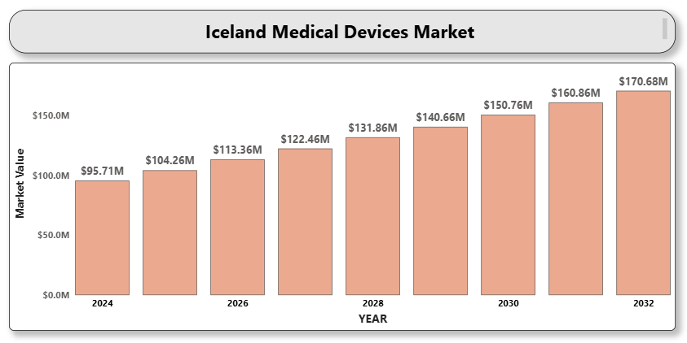

The growth of the market is driven by Iceland's advanced healthcare infrastructure, rising prevalence of chronic diseases, an aging population, and increasing focus on healthcare digitization. The country has a high per capita healthcare expenditure and ranks among the top globally for access to quality healthcare services.

**Iceland medical devices** **Market Definition**

Medical devices are instruments, apparatuses, machines, implants, in vitro reagents, or similar articles used for the diagnosis, prevention, monitoring, treatment, or alleviation of disease or injury. These devices range from simple tools such as syringes and thermometers to complex technologies like MRI machines, pacemakers, and robotic surgical systems.

In Iceland, the medical devices market encompasses a wide range of products used across hospitals, diagnostic centers, outpatient facilities, home care settings, and specialty clinics. The market includes consumables, diagnostic imaging equipment, therapeutic devices, patient monitoring systems, and digital health technologies. These devices are regulated under Icelandic and EU medical device regulations ensuring safety, efficacy, and quality.

**Iceland medical devices Market Overview**

There is growing adoption of diagnostic imaging devices such as MRI, CT, and ultrasound systems due to increasing demand for early disease detection. Similarly, the demand for surgical instruments, orthopedic implants, and cardiovascular devices is expanding with the rise in elective procedures and chronic conditions such as osteoarthritis and heart disease.

Iceland's remote geography and dispersed population are prompting healthcare providers to adopt telemedicine and remote patient monitoring solutions. Digital health technologies, including wearable devices and connected care platforms, are gaining traction especially in home care settings.

Public and private healthcare institutions in Iceland procure medical devices through tenders and long-term supplier agreements. There is significant emphasis on ensuring compliance with European CE marking, post-market surveillance, and device traceability under the EU Medical Device Regulation (MDR).

Collaborations with Scandinavian and EU countries are facilitating technology transfers, joint R&D, and access to cutting-edge innovations. International medical device manufacturers often operate through regional distributors or direct supply agreements with Icelandic hospitals and procurement agencies.

**Iceland medical devices Market Segment Analysis**

**By Type**

* Diagnostic Imaging Devices
* Therapeutic Devices
* Surgical Devices
* Monitoring Devices
* Consumables & Disposables
* Digital Health Solutions

**By End Use**

* Hospitals
* Ambulatory Surgical Centers
* Diagnostic Centers
* Home Healthcare
* A close-up of hands holding a tablet and a pen

  Description automatically generatedSpecialty Clinics

**Competitive Landscape**

The Iceland medical devices market is moderately fragmented, with several multinational corporations and regional distributors operating across different segments. Companies focus on providing high-quality, EU-compliant devices with robust after-sales support, training, and integration services.

Digital transformation, customization of devices for smaller populations, and interoperability with Iceland’s electronic health record (EHR) systems are critical focus areas for competition. Partnerships with local healthcare providers and government agencies offer a strategic edge in public sector procurement.

**Key Profiles of Iceland medical devices market**

* Medtronic plc
* Siemens Healthineers
* GE HealthCare
* Philips Healthcare
* Johnson & Johnson
* Stryker Corporation
* Abbott Laboratories
* Boston Scientific Corporation
* Becton, Dickinson and Company (BD)
* Smith & Nephew plc
* Zimmer Biomet
* Canon Medical Systems
* 3M Health Care
* A close-up of hands holding a tablet and a pen

  Description automatically generatedResMed Inc.
* Drägerwerk AG & Co. KGaA

**Key Developments**

* **In 2025**, HALO—a startup founded by six ambitious students—launched the SpritBand, a hygiene-focused bracelet designed to reduce infection risk by promoting hand cleanliness. Durable and suitable for any environment, it supports flu and germ prevention through convenient, on-the-go sanitation.
* ​**In June 2024**, Iceland Health and the Icelandic Dental Association signed a landmark five-year agreement to expand dental care funding for children, the elderly, and disabled individuals. This initiative enhances government coverage for various dental treatments, including procedures previously not subsidized, thereby promoting equitable access to oral healthcare across the nation.

**Market Attractiveness**

Iceland's high healthcare standards, digital readiness, and alignment with EU medical device regulations make it an attractive market for innovative medical technologies. The demand for precision diagnostics, personalized therapies, and remote care solutions presents growth opportunities for both global and regional players.

**Porter’s Five Forces Analysis**

* **Threat of New Entrants:** Moderate – Entry barriers include regulatory compliance and small market size.
* **Bargaining Power of Suppliers:** Moderate – High-tech components limit supplier choice, but multiple global vendors exist.
* **A close-up of hands holding a tablet and a pen

  Description automatically generatedBargaining Power of Buyers:** High – Healthcare institutions demand value-driven, reliable, and service-supported solutions.
* **Threat of Substitutes:** Low to Moderate – Technological advancements often enhance rather than replace device functions.
* **Competitive Rivalry:** High – Intense competition among global firms with strong distribution partnerships.

**Table of Contents**

1. **Introduction of Iceland Medical Devices Market**
   * 1.1 Overview of the Market
   * 1.2 Scope of Report
   * 1.3 Assumptions
2. **Executive Summary**
3. **Research Methodology**
   * 3.1 Data Mining
   * 3.2 Validation
   * 3.3 Primary Interviews
   * 3.4 List of Data Sources
4. **Iceland Medical Devices Market Outlook**
   * 4.1 Market Definition
   * 4.2 Market Overview
   * 4.3 Porter’s Five Forces Model
   * 4.4 Value Chain Analysis
5. **Market, by Type**
   * 5.1 Diagnostic Imaging Devices
   * 5.2 Therapeutic Devices
   * 5.3 Surgical Devices
   * 5.4 Monitoring Devices
   * 5.5 Consumables & Disposables
   * 5.6 Digital Health Solutions
6. **Market, by End Use**
   * 6.1 Hospitals
   * 6.2 Ambulatory Surgical Centers
   * 6.3 Diagnostic Centers
   * 6.4 Home Healthcare
   * 6.5 Specialty Clinics
7. **Competitive Landscape**
   * A close-up of hands holding a tablet and a pen

     Description automatically generated7.1 Overview
   * 7.2 Company Market Ranking
   * 7.3 Key Development Strategies
8. **Company Profiles**

**8.1 Medtronic plc**  
8.1.1 Overview  
8.1.2 Financial Performance  
8.1.3 Product Outlook  
8.1.4 Key Developments

**8.2 Siemens Healthineers**  
8.2.1 Overview  
8.2.2 Financial Performance  
8.2.3 Product Outlook  
8.2.4 Key Developments

**8.3 GE HealthCare**  
8.3.1 Overview  
8.3.2 Financial Performance  
8.3.3 Product Outlook  
8.3.4 Key Developments

**8.4 Philips Healthcare**  
8.4.1 Overview  
8.4.2 Financial Performance  
8.4.3 Product Outlook  
8.4.4 Key Developments

**8.5 Johnson & Johnson**  
8.5.1 Overview  
8.5.2 Financial Performance  
8.5.3 Product Outlook  
8.5.4 Key Developments

**8.6 Stryker Corporation**  
8.6.1 Overview  
8.6.2 Financial Performance  
8.6.3 Product Outlook  
8.6.4 Key Developments

**8.7 Abbott Laboratories**  
8.7.1 Overview  
8.7.2 Financial Performance  
8.7.3 Product Outlook  
8.7.4 Key Developments

**8.8 Boston Scientific Corporation**  
8.8.1 Overview  
8.8.2 Financial Performance  
8.8.3 Product Outlook  
8.8.4 Key Developments

**8.9 Becton, Dickinson and Company (BD)**  
8.9.1 Overview  
8.9.2 Financial Performance  
8.9.3 Product Outlook  
8.9.4 Key Developments

**8.10 Smith & Nephew plc**  
8.10.1 Overview  
8.10.2 Financial Performance  
8.10.3 Product Outlook  
8.10.4 Key Developments

**8.11 Zimmer Biomet**  
8.11.1 Overview  
8.11.2 Financial Performance  
8.11.3 Product Outlook  
8.11.4 Key Developments

**8.12 Canon Medical Systems**  
8.12.1 Overview  
8.12.2 Financial Performance  
8.12.3 Product Outlook  
8.12.4 Key Developments

**8.13 3M Health Care**  
8.13.1 Overview  
8.13.2 Financial Performance  
8.13.3 Product Outlook  
8.13.4 Key Developments

**8.14 ResMed Inc.**  
8.14.1 Overview  
8.14.2 Financial Performance  
8.14.3 Product Outlook  
8.14.4 Key Developments

**8.15 Drägerwerk AG & Co. KGaA**  
8.15.1 Overview  
8.15.2 Financial Performance  
8.15.3 Product Outlook  
8.15.4 Key Developments

1. **Key Developments**
   * 9.1 Product Launches/Developments
   * 9.2 Mergers and Acquisitions
   * 9.3 Business Expansions
2. **Appendix**
   * 10.1 Related Research